# Title: Stock Market Investment Platform

1. **Project Statement:**

The project aims to develop a user-friendly web application that provides comprehensive tools to help users manage their investment portfolios. It offers real- time market data, portfolio tracking, market analysis, and educational resources, streamlining the investment process for both novice and experienced investors.

# Outcomes:

* + Allow users to create and manage their investment portfolios.
  + Provide real-time stock market data for users to track stock performance.
  + Enable users to analyze market trends and make informed investment decisions.
  + Enhance user engagement with educational resources and news.
  + Provide a seamless and intuitive user interface for portfolio and market management.

**Modules to be Implemented:**

1. **User Authentication and Registration**
2. **Portfolio Management Interface**
3. **Stock Market Data and Visualization**
4. **Budget Management**
5. **Notification System** (Future Scope)
6. **Learning Resources**
7. **Dashboard**

**Week-wise Module Implementation and High-Level Requirements with Output Screenshots**

**Milestone 1: Weeks 1-3**

**Module 1: User Authentication and Registration**

* + Implement user registration functionality.
  + Develop user login mechanism.
  + Integrate email verification and password reset features.

# Output Screenshot:

* + - User login/registration page.

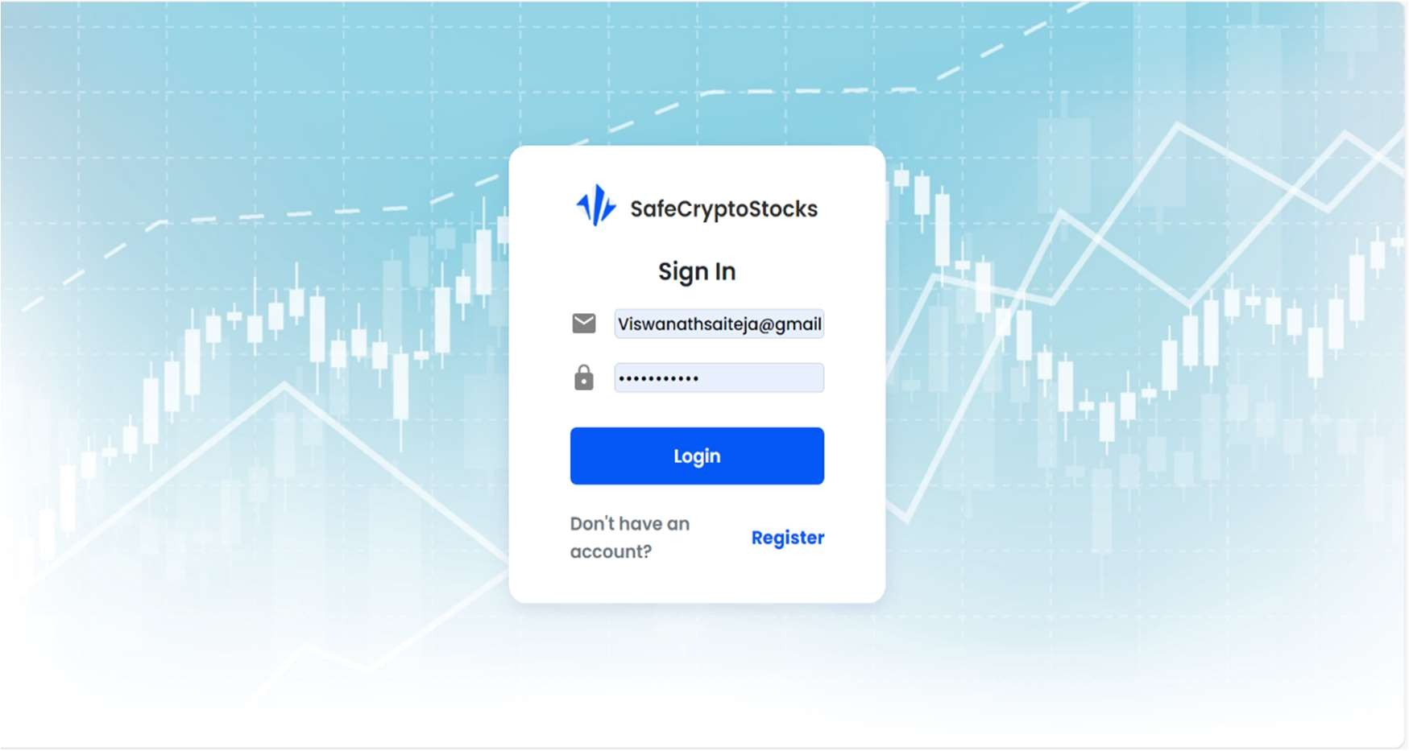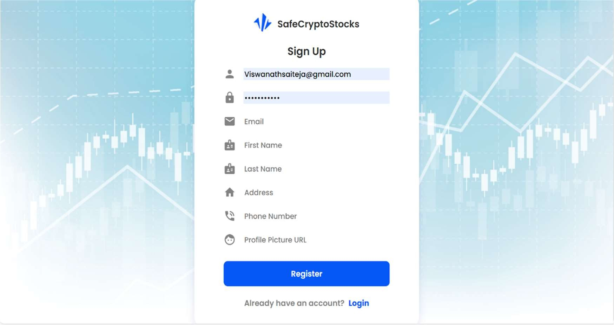

# Module 2: Portfolio Management Interface

* + Design the database schema for storing portfolio information.
  + Develop an interface for users to add, edit, and manage their portfolios.
  + Implement backend logic to handle portfolio calculations (total value, gains, etc.).

# Output Screenshot:

* + - Portfolio management screen.

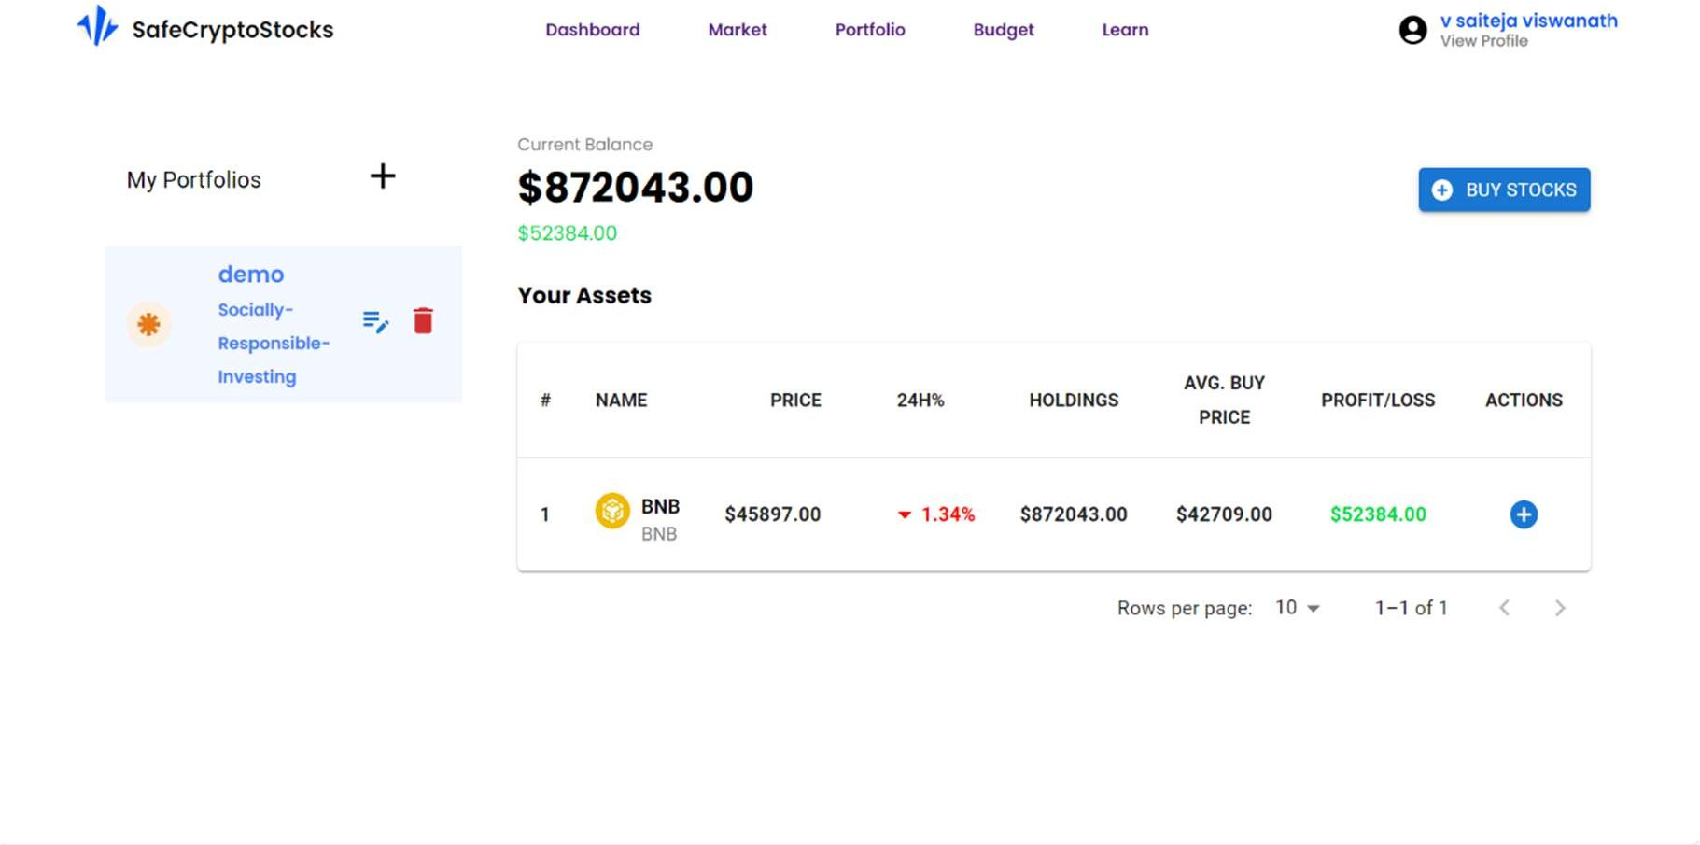

# Milestone 2: Weeks 4-5

**Module 3: Stock Market Data and Visualization**

* + Design and implement an interface to display real-time stock market data.
  + Integrate stock APIs to fetch live stock prices and details.
  + Visualize market trends using charts and graphs.

# Output Screenshot:

* + - 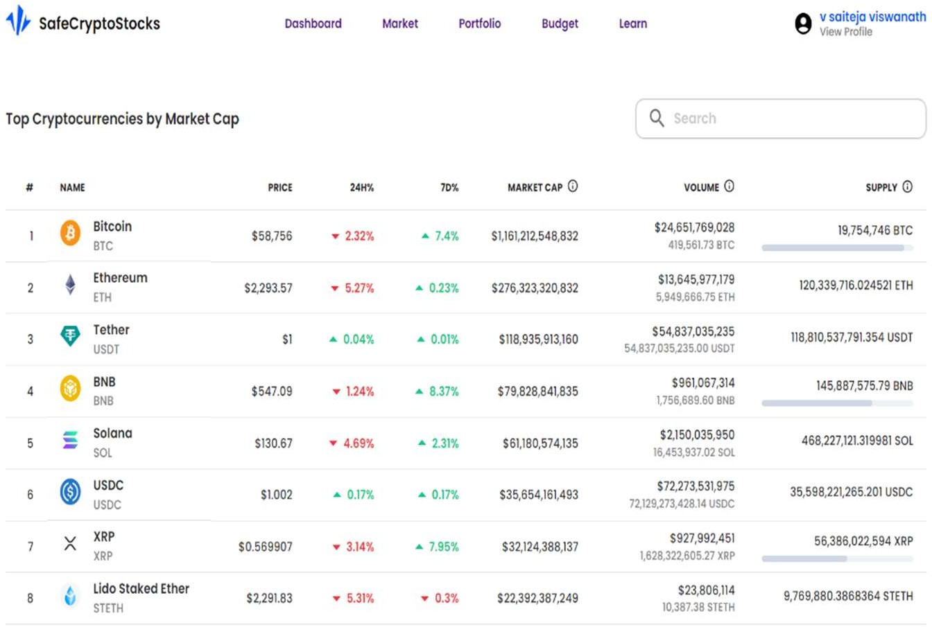Stock market data visualization page

e.

# Module 4: Dashboard

* + Design the dashboard interface to provide an overview of the user’s portfolio.
  + Display total portfolio value, daily changes, and top-performing/underperforming stocks.
  + Integrate market news updates relevant to user holdings.

# Output Screenshot:

* + - Dashboard showing portfolio overview and market news.

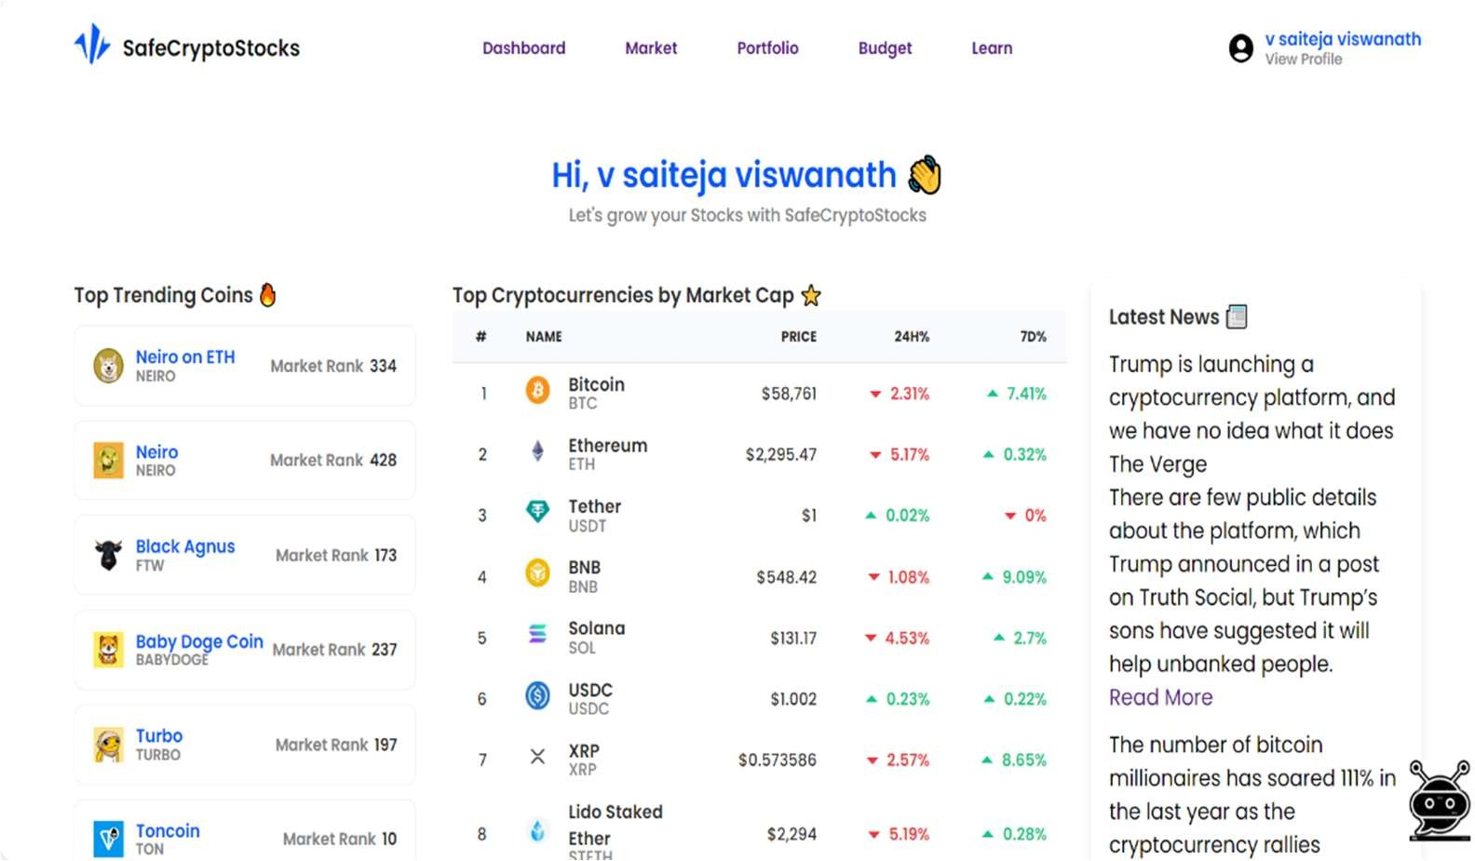

# Milestone 3: Weeks 6-7

# Module 5: Budget Management

* + Design a database schema for storing user budgets and expenses.
  + Implement functionality for users to set budget limits and track expenses.
  + Develop backend logic for calculating spending trends and budget adherence.

# Output Screenshot:

* + - Budget management screen.

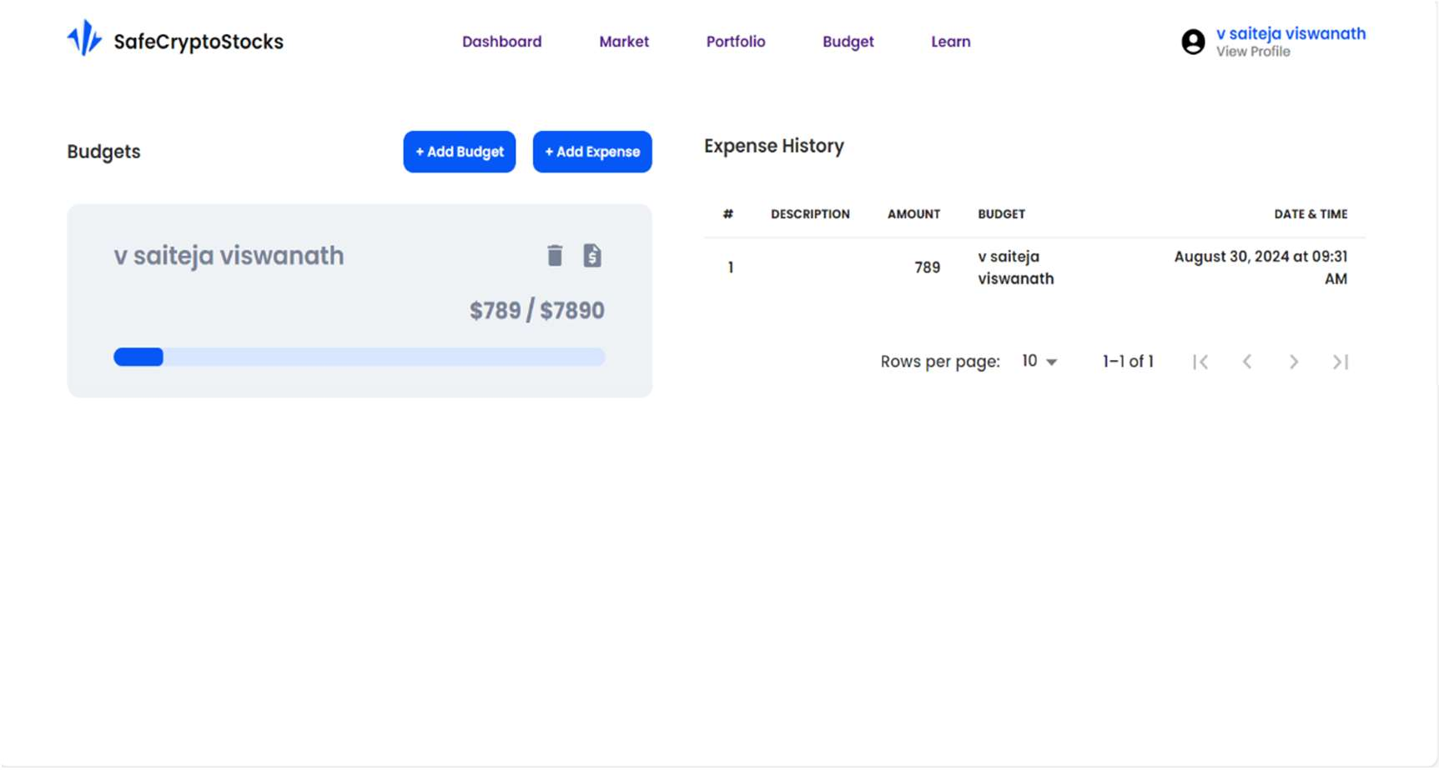

# Milestone 4: Weeks 8-10 Module 6: Learning Resources

* + Provide educational articles, videos, and tutorials on stock market investing.
  + Implement quizzes and learning activities for users to improve financial literacy.

# Output Screenshot:

* + - Learning resources interface.

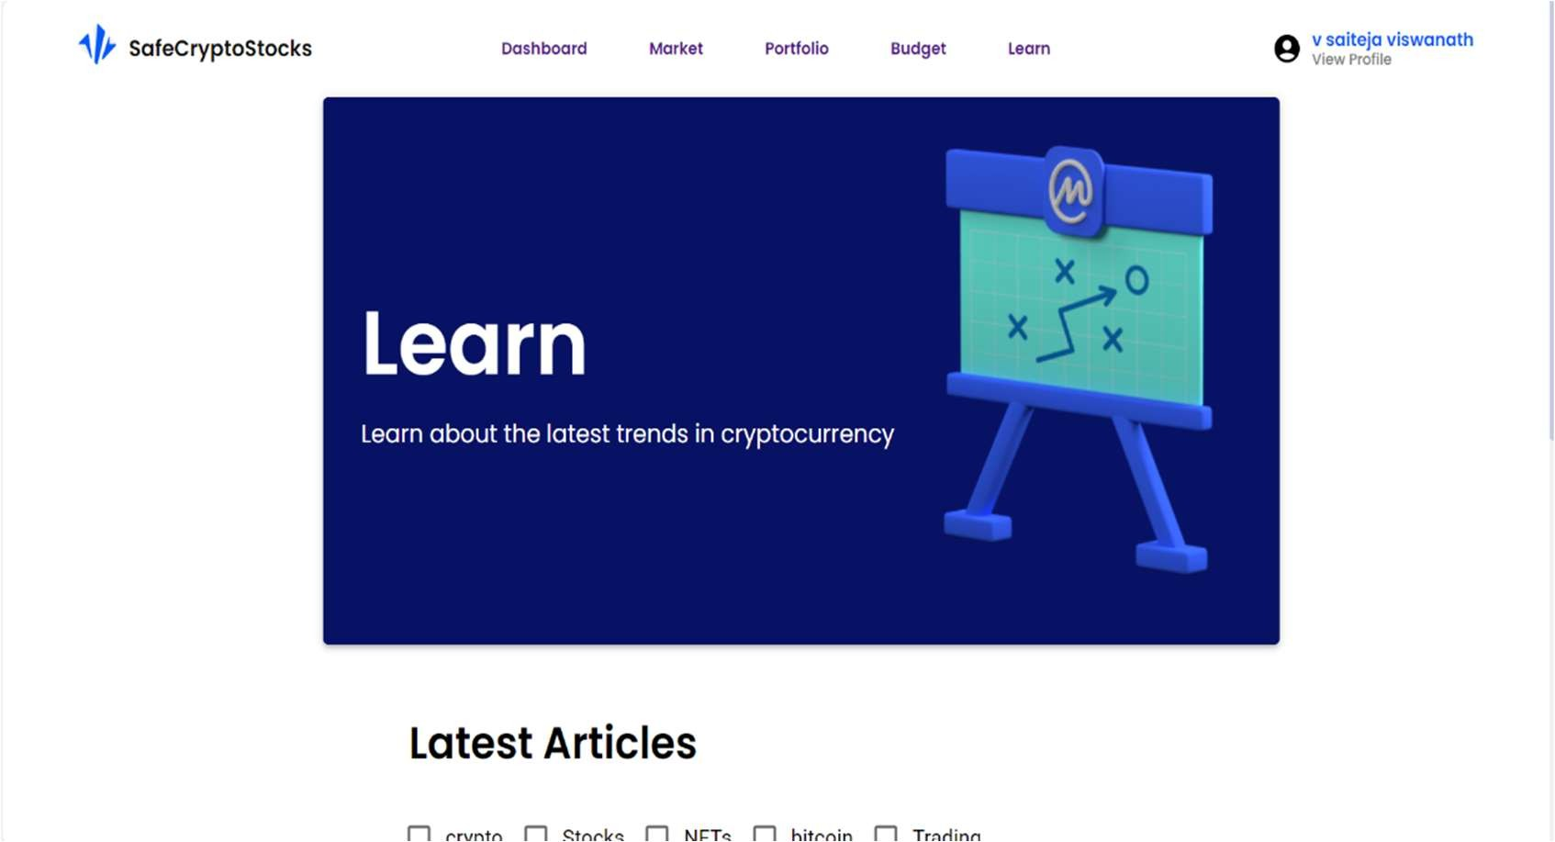

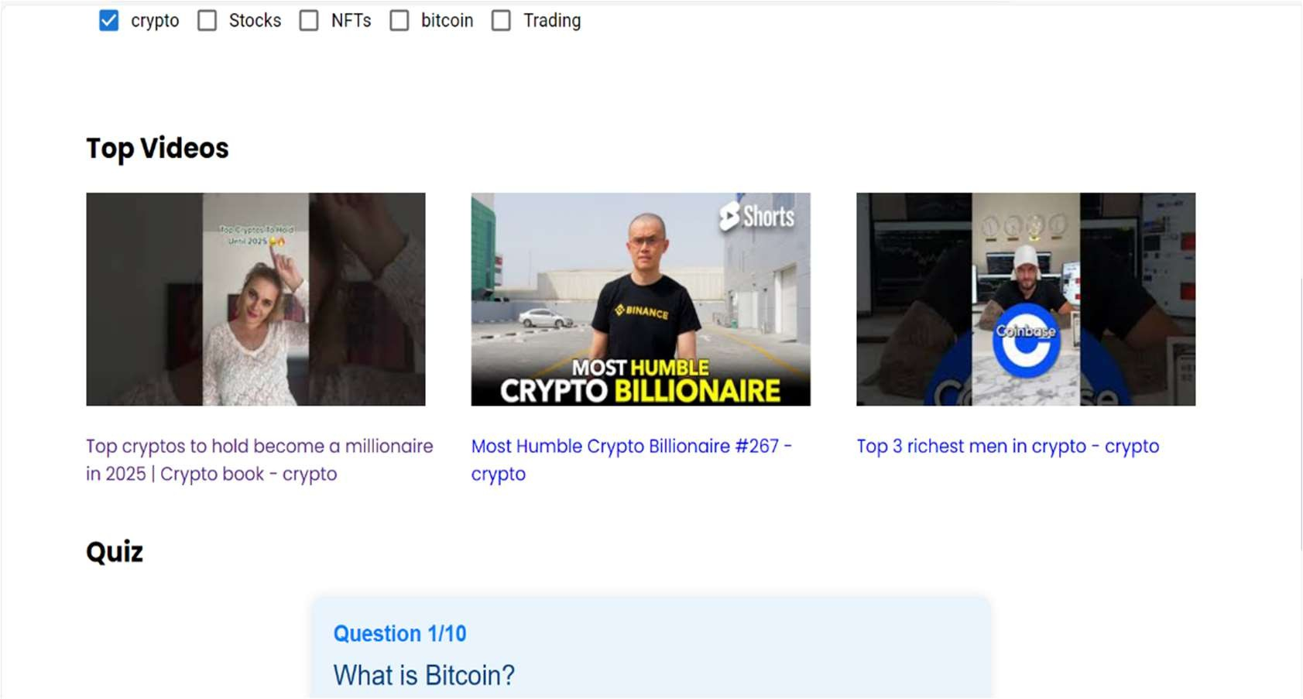

# Evaluation Criteria

**Milestone 1 Evaluation (Week 3):**

* + Completion of user authentication and registration.
  + Implementation of the portfolio management interface.

# Milestone 2 Evaluation (Week 5):

* + Development and integration of stock market data and visualization.
  + Dashboard module operational with market news and portfolio insights.

# Milestone 3 Evaluation (Week 7):

* + Budget management system operational and integrated.

# Milestone 4 Evaluation (Week 10):

* + Educational resources are fully implemented and available for users.

# Design Diagrams

1. **Class Diagram: Entity Classes**
   * Includes entities like User, Portfolio, Stock, Transaction, Budget.

# Class Diagram: Service Interface

* + Defines interactions for PortfolioService, BudgetService, StockService.

# Class Diagram: Repository

* + MongoDB collections for storing user, portfolio, stock, and budget data.

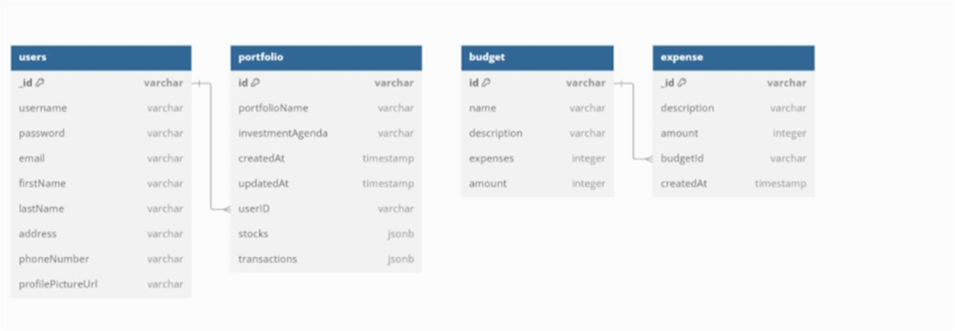

# Output Screenshots:

1. **Dashboard**: Portfolio overview with market news.
2. **Budget Management**: Budget tracking interface.

